**SERIS**

Solar Energy Research Institute Singapore



Cloud Based Real-time Analytical Monitoring of Photovoltaic Systems

Use Case Model Survey (UCMS)

|  |  |
| --- | --- |
| Filing Reference | SE25PT7SERIS/TECH/ANALYSIS/UCMS/WORK IN PROGRESS/TUCMS.doc |
| Document Title | Use Case Model Survey |
| Version | 1.0 |
| Author | Kaung Myat Bo |
| Date Created |  |

|  |  |  |
| --- | --- | --- |
| **Approved by:** | | |
| Name | Designation | Date |
|  |  |  |
| **Authorized by:** | | |
| Name | Designation | Date |
|  |  |  |

**Revision History**

|  |  |  |  |
| --- | --- | --- | --- |
| **Revision** | **Date** | **Author** | **Description** |
|  |  |  |  |
|  |  |  |  |
|  |  |  |  |
|  |  |  |  |
|  |  |  |  |
|  |  |  |  |
|  |  |  |  |
|  |  |  |  |

|  |  |  |  |
| --- | --- | --- | --- |
| **For Internal use** | | **Date** | **Department** |
| Authorized By |  |  |  |
| Released By |  |  |  |

Table of Contents

1 Use case diagrams 4

1.1 Primary Use Cases Diagram 4

2 Actors 6

2.1 Device 6

2.2 System User 6

2.3 Admin 6

2.4 LogParser 6

2.5 Syncer 6

3 Use cases 6

3.1 Login 6

3.2 Maintain personas 6

3.3 Maintain users 7

3.4 Maintain stations 7

3.5 Maintain station configs 7

3.6 Update configuration 7

3.7 View/select user(s) 7

3.8 View/Select station(s) 7

3.9 View/select persona 7

3.10 View/select station config 8

3.11 Send unstructured(raw) data 8

3.12 Transform raw data to structured data 8

3.13 Synchronize structured data 8

3.14 Download history data 8

3.15 View real-time station information 8

3.16 View station history information 8

3.17 Forget password 8

3.18 Reset password 9

# Use case diagrams

## Primary Use Cases Diagram

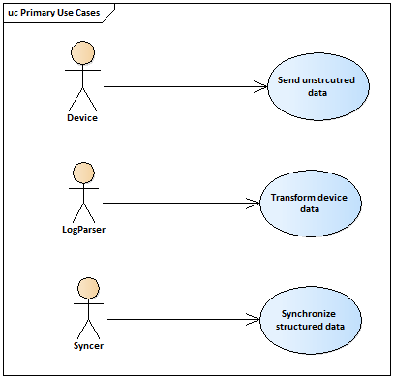

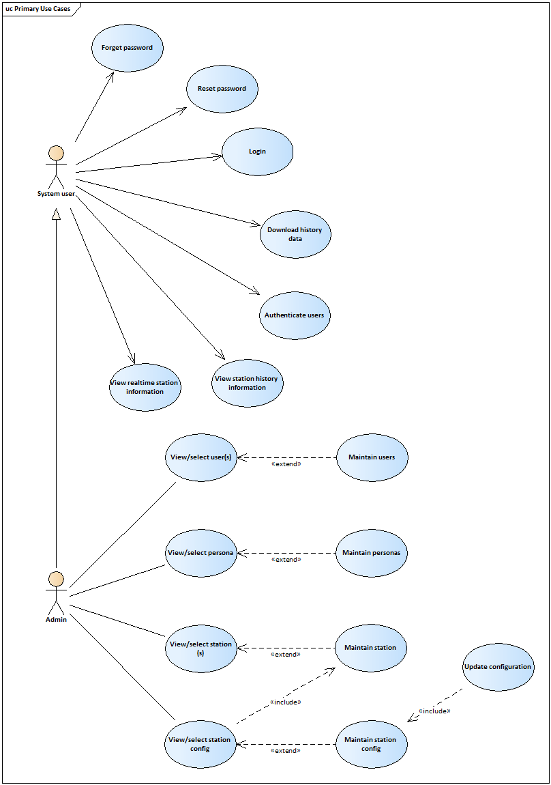

# Actors

All Actors in the system are contained in this package. This is both as a way to organize the model, making it easier to understand, and to provide a way to manage the actors in a single configuration item. If different individuals are responsible for different actors and their related artifacts, the actors should be organized into their own packages and placed under separate configuration control.

## Device

This actor represents PV system device which is responsible for sending data to the cloud service. It will also send the device health statistics to the application, which is deployed on the cloud, via Virtual Private Cloud.

## System User

This actor represents the different type of users(personas) who will monitor the assigned real time data and device health statistics, which will be sent from various devices, in rich user interfaces.

## Admin

This actor represents the root user who can create and maintain users, roles, stations information, maintain station parameter config and maintain station record access. This user will have other common access that the system user has.

## LogParser

This actor represents an application which will get the raw data from Amazon S3 and transform into structured (field, value) data. After the transformation, structured data will be stored directly into NoSQL database.

## Syncer

This actor represents a web socket application or SSE application which will get the structured data from NoSQL database and send data to browsers.

# Use cases

## Login

The aim of this use case is to enable users to log-in to the system using a unique email address and password. Associated with each username is a system access level which is used to determine the system functions and records that can be accessed.

## Maintain personas

The aim of this use case is to enable the administrator to create, update, view and delete existing personas (user groups). This used case is extended in View/Select person use case.

## Maintain users

The aim of this use case is to enable the administrator to create, update and view user information. Also, the use case enables the system administrator to reset passwords, change access rights and deactivate/activate accounts for the existing users. This used case is extended in View/Select user use case.

## Maintain stations

The aim of this use case is to enable the administrator to create, update, view and activate/deactivate the existing station in the system. This use case in extended in View/Select station use case.

## Maintain station configs

The aim of this use case is to enable the administrator to create, update, view and delete the configurations for each existing station. Two types of configuration, station data parameter and station health parameter will be maintained in this use case. Those configurations will be used to transform raw data into structured data. This use case in extended in View/Select station use case.

## Update configuration

This aim of this use case is to update the configuration file, is a file which contain configurations for each station to parse raw data into structured data, of LogParser, which is an application. This used is included in Maintain station configs use case. Whenever there is a change in station config, this use case will be triggered to update the configuration file.

## View/select user(s)

The aim of this abstract use case is to enable the admin to search the users by name and then able to view a list of users as a search result. The admin is also able to select one of the users to see the detailed information of the user. For creating, modifying and activation/deactivation of a user can be done by triggering Maintain Users use case from this use case.

## View/Select station(s)

The aim of this abstract use case is to enable the admin to search the stations by name and then able to view a list of stations as a search result. The admin is also able to select one of the stations to see the detailed information of the station. For creating, modifying and activation/deactivation of a station can be done by triggering Maintain Stations use case from this use case.

## View/select persona

The aim of this abstract use case is to enable the admin to view a list of existing personas. The admin is also able to view persona detail by selecting one of the personas from the list. Maintain personas use case can be triggered from this used to create, modify and delete the existing persona.

## View/select station config

The aim of this abstract use case is to enable the admin to view a list of existing station configurations. The admin is able to view the detailed station configurations (data parameter configurations and health configurations) by selecting the existing station on the list. Maintain station config use case will be triggered from this use case for the admin to create new station configuration or modify/delete the existing configuration.

## Send unstructured(raw) data

The aim of this use case is for the devices to send raw data into the system. There are 3 types of data, which are one-second data, one-minute data and station health data, and these types of raw data will be stored into Amazon S3 storage and waiting to be processed to transform structured data.

## Transform raw data to structured data

The aim of this use case is to transform raw data records from Amazon S3 into structured data. Raw data will be parsed based on a configuration file and configurations for each of station will be stored in that file to be used by LogParser.

## Synchronize structured data

The aim of this use case is to send structured data (one-second, one-minute and health data) to browsers.

## Download history data

The aim of this use case is to enable the user to download the history data from the system for other purposes. The user shall download the data in CSV format from the system based on the date range and selected parameters.

## View real-time station information

The aim of this use case is to enable the user to view the real-time station information (weather and system health) on the Web Page.

## View station history information

The aim of this use case is to enable the user to view history record of the stations. The user shall view the history record in various Rich User Interfaces.

## Forget password

The aim of this use case is to enable the user to request an one-time reset password link to reset a new password when they forget their own password.

## Reset password

The aim of this use case is to enable the user to reset a new password by using one-time reset password link.